PROJECT REPORT OF INDUSTRY ORIENTED HANDS ON EXPERIENCE (IOHE)
ON
Social Media Algorithm and political polarization
submitted in partial fulfilment of the requirements for the award of degree of

BACHELOR OF ENGINEERING
In
COMPUTER SCIENCE AND ENGINEERING

Submitted by: Supervised By:
Ankush Sharma - 2210991282 Dr. Ajay Kumar
Bhupesh Relan – 2210991447 Associate Professor
Anuj Anand – 2210991315 Chitkara University
Chirag - 2210991466


DEPARTMENT OF COMPUTER SCIENCE AND ENGINEERING

CHITKARA UNIVERSITY INSTITUTE OF ENGINEERING AND TECHNOLOGY
CHITKARA UNIVERSITY, PUNJAB, INDIA

DECLARATION

I hereby certify that the work which is being presented in the project report entitled “Social Media Algorithm and political polarization” in partial fulfilment of requirement for the award of the degree of Bachelor of Engineering (Computer Science and Engineering) submitted in the department of Computer Science and Engineering at Chitkara University Institute of Engineering and Technology, Chitkara University, Punjab, India, is an authentic record of my own work carried out under the supervision of Dr. Ajay Kumar The matter presented in this project report has not been submitted in any other university/institute for the award of any degree.

Place: Rajpura Ankush Sharma - 2210991283
Date: …………….. Bhupesh Relan – 2210991447
Anuj Anand – 2210991315
Chirag - 2210991466
This is to certify that the above statement made by the candidate is correct to the best of my knowledge and belief.

Dr. Ajay Kumar
Associate Professor
Department of Computer Science and Engineering
Chitkara University Institute of Engineering and Technology,
Chitkara University, Punjab, India

ACKNOWLEDGEMENT
I would like to express my sincere gratitude to my guide, teachers, and the Department of Computer Science & Engineering at Chitkara University for their continuous support and guidance throughout the completion of this research paper. Their valuable suggestions and encouragement helped me understand the topic in depth and complete the research successfully.
I would also like to thank my friends and classmates for their cooperation and motivation during the research work. Special thanks to my family members for their constant support and encouragement.
Finally, I am grateful to all the online resources, research papers, journals, and articles that provided valuable information related to social media and political polarization.

Table Of Content:

S.No. | Title | Page No.
 | Acknowledgements | 3
 | Abstract | 5
1. | Introduction | 6
2. | Methodology | 7
3. | Tools and Technologies | 8
4. | Implementation | 9
5. | Major Findings/Outcomes/Output/Results | 10
6. | Conclusion and Future Scope | 13
 | References | 13

Abstract :
Algorithms on social media sites decide what content users see in their feeds. The main purpose of these algorithms is to keep people interested by showing them posts that they are more likely to like, share, or comment on. However, this system can also cause problems in online political discussions. Algorithms often promote content that is emotional, dramatic, or strongly opinionated, because this type of content gets more views. As a result, users might mostly see posts that agree with their existing beliefs.
This can lead to echo chambers, where people only hear the same opinions and rarely see things from a different point of view. Over time, this can make politics more divided and make online discussions less open. This study looks at how algorithms on social media affect political polarization. The study starts by looking at research papers, articles, and real-world examples from fields like political science and media studies. These sources help us understand how recommendation systems work and how they might affect the political content people see online. This research goes beyond a simple literature review; it also includes the development of a machine learning model. This model is trained on social media data to find patterns in political posts, how users interact with them, and how opinion-based information spreads.
The results show that algorithms designed to maximize engagement often promote more extreme or emotionally charged content because it gets more user interaction. This can strengthen existing beliefs, reduce openness to new ideas, and speed up the spread of misleading information. In addition, the machine learning analysis shows that users who frequently engage with political content tend to see more of the same type of content over time.
The research findings indicate that while algorithms contribute to content personalization, their unchecked application could intensify political polarization. To mitigate these potential dangers, the study advocates for increased algorithm transparency, the implementation of more robust regulations for online platforms, and the promotion of digital literacy, thereby enabling users to better understand and critically evaluate the information encountered online.

1. Introduction:
Social media has transformed the way people communicate, share information, and participate in political discussions. Over the last decade, the rise of digital platforms has changed traditional communication systems and created new opportunities for political engagement. Millions of users actively express opinions, follow political leaders, and consume news through social networking platforms.
Political polarization refers to the division of political attitudes into extreme ideological groups. In recent years, this polarization has increased significantly due to the influence of social media platforms. Algorithms used by social media applications often recommend content based on users’ interests and previous interactions. As a result, users are repeatedly exposed to similar opinions, which strengthens their beliefs and reduces exposure to opposing viewpoints.
Social media platforms also allow rapid spread of misinformation, fake news, and emotionally charged content. Such content can influence voters, manipulate public opinion, and increase conflicts among different political groups. Political campaigns now heavily depend on targeted advertisements and digital strategies to influence citizens.
Despite these challenges, social media also provides several advantages. It promotes awareness, enables freedom of expression, and encourages political participation among young people. Citizens can discuss important social and political issues openly and interact directly with leaders and organizations.
This research aims to study how social media contributes to political polarization, analyze its effects on society, and identify methods to reduce negative impacts while maintaining healthy democratic discussions.

2. METHODOLOGY:
The methodology used in this research paper focuses on analyzing the relationship between social media usage and political polarization. Both qualitative and quantitative approaches were considered during the research process.
Research Steps
- Selection of research topic
- Collection of data from journals, articles, surveys, and online reports
- Analysis of social media trends and political discussions
- Study of algorithmic recommendation systems
- Evaluation of findings and conclusions
Data Collection Methods
- Research papers and journals
- Online surveys and questionnaires
- News articles and reports
- Government and institutional reports
- Case studies related to elections and online campaigns
Research Approach
The research follows a descriptive and analytical approach to understand how social media influences public opinion and political behavior. Various examples from different countries were studied to observe how online discussions impact political ideologies.
Limitations
- Limited access to real-time private social media data
- Possibility of biased online survey responses
- Rapidly changing political trends and algorithms

3. TOOLS AND TECHNOLOGIES:
The research work was implemented using Python in Google Colab for data analysis, preprocessing, visualization, and machine learning model development. Public datasets related to social media discussions and political opinions were collected from Kaggle.
The following tools, technologies, and libraries were used during the research process:
Tool/Technology | Purpose
Google Colab | Writing and executing Python code online
Python | Data analysis and machine learning
Kaggle Datasets | Collecting social media and political data
Pandas | Data cleaning and manipulation
NumPy | Numerical computations
Matplotlib | Data visualization and graph plotting
Seaborn | Statistical data visualization
Scikit-learn | Machine learning model creation and evaluation
VADER Sentiment | Sentiment analysis of social media text
Zip file & OS Modules | Handling dataset files and directories

Programming Language Used
- Python
Python Libraries Used
- Pandas
- NumPy
- Matplotlib
- Seaborn
- Scikit-learn
- VADER Sentiment
- SciPy
Machine Learning Model
A machine learning-based sentiment analysis model was developed to analyze political discussions and opinions shared on social media platforms. The model processes textual data and classifies sentiments into positive, negative, or neutral categories.
The workflow of the model includes:
- Dataset collection from Kaggle
- Data preprocessing and cleaning
- Sentiment analysis using VADER Sentiment
- Feature extraction from text data
- Training and testing using Scikit-learn
- Visualization of results using graphs and charts

4. IMPLEMENTATION:
The implementation phase focused on analyzing social media behavior and identifying patterns related to political polarization.
Implementation Process
- Data was collected from publicly available sources and surveys.
- The collected data was cleaned and organized using Excel and Python libraries.
- Sentiment analysis techniques were applied to identify positive, negative, and neutral political opinions.
- Graphs and visualizations were created to understand user engagement patterns.
- Comparative analysis was conducted between different social media platforms.
Key Areas of Analysis
- Political discussions on social media
- Spread of misinformation and fake news
- User engagement with political content
- Influence of recommendation algorithms
- Formation of echo chambers
Sentiment Analysis
Natural Language Processing (NLP) techniques were used to analyze political comments and discussions. The sentiment analysis helped classify opinions into different emotional categories and understand public reactions toward political topics.
Algorithmic Influence
Recommendation systems on social media platforms prioritize content that increases engagement. This often leads users toward extreme or emotionally engaging political content, increasing ideological division.
5. MAJOR FINDINGS / OUTCOMES / RESULTS
The research identified several important findings related to social media and political polarization.
Major Findings
- Social media significantly influences political opinions and public discussions.
- Personalized recommendation algorithms increase exposure to similar viewpoints.
- Echo chambers reduce interaction with opposing political ideologies.
- Fake news and misinformation spread rapidly through social media platforms.
- Emotionally charged political content receives higher engagement.
- Young users are more influenced by political trends on social media.
- Political advertisements and targeted campaigns impact voter behavior.
Observed Outcomes
- Increased ideological divisions among users
- Reduced trust in traditional media sources
- Higher political participation among youth
- Growth in online political activism
- Increased online conflicts and debates
Statistical Observations
- Most users consume political news through social media platforms rather than newspapers or television.
- Users who spend more time on politically biased content are more likely to develop extreme political opinions.
- Misinformation spreads faster than factual news due to emotional engagement and sharing behavior.

Some graphs:
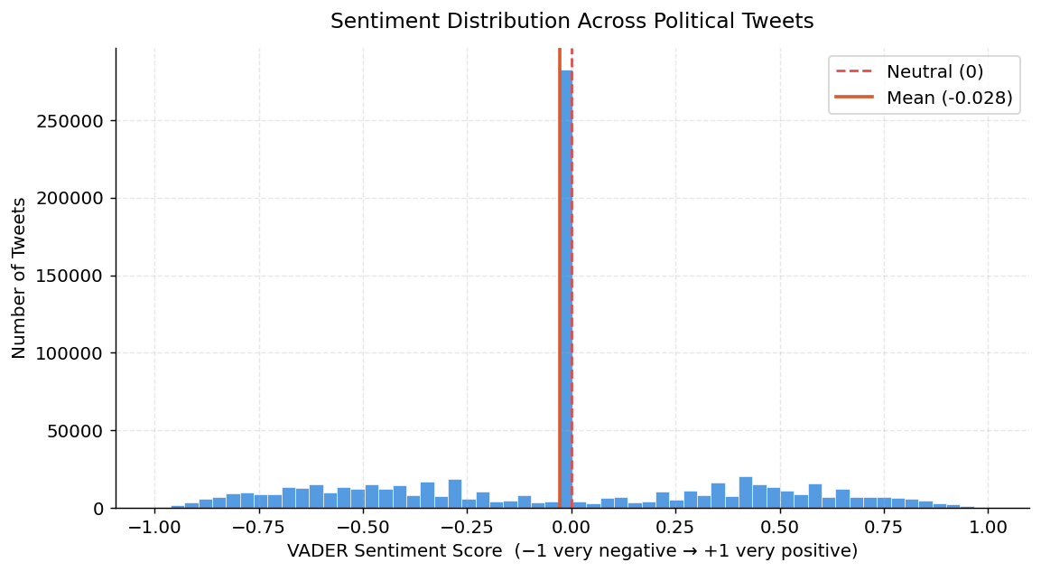

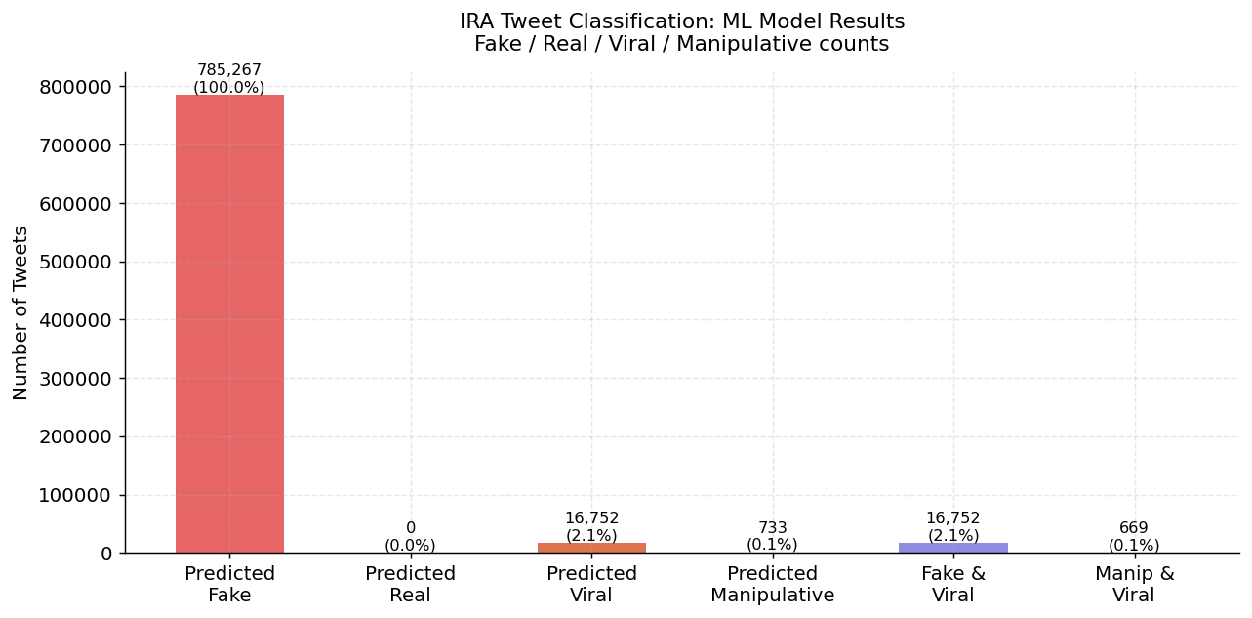

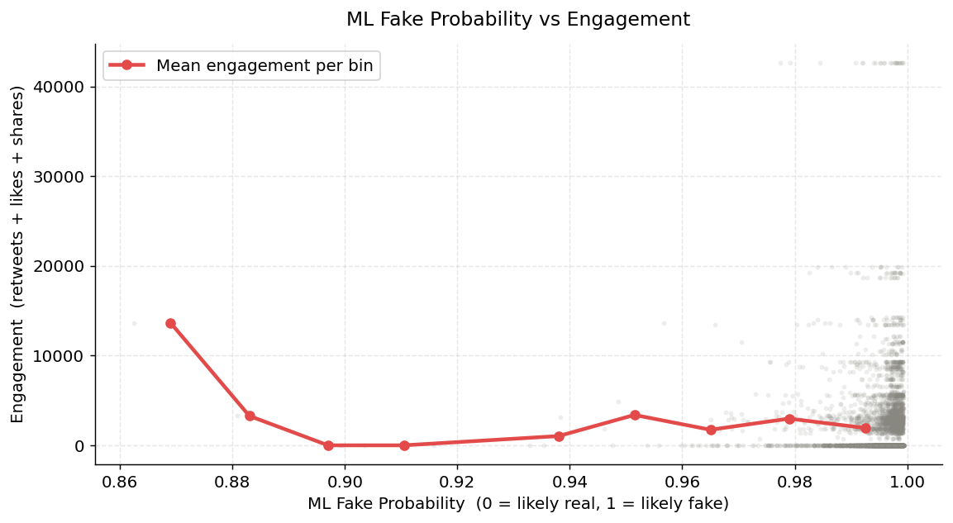

6. CONCLUSION AND FUTURE SCOPE
Social media has become a powerful tool for communication, political awareness, and public participation. However, it also plays a major role in increasing political polarization by creating echo chambers, spreading misinformation, and promoting biased political discussions. Algorithms designed to maximize user engagement often expose individuals to repetitive ideological content, which strengthens divisions in society.
Despite these challenges, social media can still contribute positively to democracy when used responsibly. Encouraging digital literacy, promoting fact-checking systems, and improving transparency in recommendation algorithms can help reduce political polarization. Users should also be encouraged to engage with diverse viewpoints and verify information before sharing it online.
Future Scope
- Development of AI-based fake news detection systems
- Improved transparency in social media algorithms
- Research on ethical AI in political communication
- Better digital literacy programs for users
- Advanced sentiment analysis models for political research
- Cross-platform studies on political behavior
Future research can further explore how emerging technologies such as Artificial Intelligence and Machine Learning influence online political discussions and public opinion formation.

References:
1] Allcott, Hunt and Matthew Gentzkow, “Social Media and Fake News in the 2016 Election,” Journal of Economic Perspectives, vol. 31, no. 2, pp. 211–236, 2017.
2] Bovet, Alexandre and Hernán A. Makse, “Influence of Fake News in Twitter during the 2016 US Presidential Election,” Nature Communications, vol. 10, no. 7, 2019.
3] Vosoughi, Soroush, Deb Roy, and Sinan Aral, “The Spread of True and False News Online,” Science, vol. 359, no. 6380, pp. 1146–1151, 2018.
4] Kaggle, “Russian Troll Tweets Dataset,” Available: https://www.kaggle.com/datasets/fivethirtyeight/russian-troll-tweets
5] Kaggle, “Viral Social Media Trends & Engagement Analysis Dataset,” Available: https://www.kaggle.com/datasets/atharvasoundankar/viral-social-media-trends-and-engagement-analysis
6]Kaggle, “Politifact Fake News Dataset,” Available: https://www.kaggle.com/datasets/vaibhavsuman/politifact-dataset
7] Kaggle, “2016 Election Polls Dataset,” Available: https://www.kaggle.com/datasets/fivethirtyeight/2016-election-polls

